FIELD CONFIGURATION + COMMISSIONING GUIDE

PJLink Projector Control
  - Panasonic PT-VMZ51U7 for 247Golf AccessControl
Bay network architecture, Panasonic setup, AccessControl settings, commissioning tests, and booking-aware power automation
Primary model | Panasonic PT-VMZ51U7 (PT-VMZ51 family)
Protocol | PJLink Class 2 over TCP/IP
Document revision | 2.0 | 2026-07-28
Audience | Location installer, support technician, and AccessControl developer

CURRENT: AccessControl includes an authenticated PJLink client, identity and status checks, guarded manual power tests, booking-aware automatic power control, the customer Help override, the animated Projector Startup dialog, and a PJLink-first application startup gate. Enable projector control only after the physical wiring, Panasonic settings, password, identity values, and all three commissioning buttons pass.

24/7 Golf SimManager | Internal installation reference

1 Read this first
Yes - PJLink is the right base protocol. PJLink is a cross-manufacturer standard maintained by JBMIA. The Panasonic PT-VMZ51 supports both PJLink Class 1 and Class 2, so the core power and monitoring implementation can remain portable to compatible BenQ, Epson, and other models.
IMPORTANT: PJLink provides portable operational control, not portable device provisioning. Stable IP addressing, standby-network availability, projector accounts, the PJLink password, and vendor-specific power/CEC policies must be commissioned first.

1.1 Required outcome
- The projector uses one intentional wired Ethernet path and a stable IPv4 address.
- Network functions remain available while the projector is in standby.
- The Panasonic administrator account is initialized with a nonblank password.
- A unique PJLink password is configured and recorded securely.
- Power Management and HDMI-CEC do not race AccessControl's booking-driven power policy.
- The simulator PC can reach TCP port 4352 while the projector is on and while it is in standby.
- The endpoint identity is confirmed as Panasonic PT-VMZ51 and PJLink Class 2 before automation is enabled.

1.2 Current application status (2026-07-28)
Area | Implemented now | Owner / boundary
AccessControl Settings | Complete PJLink tab with enable switch, booking-gap and customer-message timing, endpoint identity, password, command timing, three commissioning buttons, and standard power commands. | Location administrator enters and tests the commissioned values.
Runtime power policy | Early Access, valid customer/Admin unlock, Help recovery, locked-kiosk refresh shutdown policy, transition serialization, and failure isolation. | AccessControl; CourtReserve refreshes remain authoritative for automatic shutdown.
Application startup | When PJLink is enabled, projector status/readiness and dialog completion are checked before Startup application Row 1, with one 60-second maximum. | AccessControl; the timeout prevents projector trouble from blocking normal application startup.
Panasonic provisioning | Manual network, standby, administrator, PJLink password, CEC, and power-management setup documented in this guide. | Installer/projector remote or Panasonic web control. PJLink is not a provisioning protocol.
Deployment Manager | Can deploy approved AccessControl configuration; a dedicated projector commissioning wizard remains a future enhancement. | Must not silently change the projector network or Panasonic menu/security settings.

1.3 Quick answer: what can software configure after the IP works?
After the IP path and Panasonic menu settings are configured manually, AccessControl can authenticate, verify the physical projector, read error and power status, test power on/off, and run the booking-aware power policy. PJLink cannot configure the projector's IP address, administrator account, PJLink password, standby mode, HDMI-CEC, or Panasonic power-management policy. Those bootstrap settings remain intentional installer tasks; Deployment Manager may distribute approved non-secret defaults later, but it should not automate the Panasonic web interface.
Capability | PJLink standard? | Recommended owner
Power on / standby / status | Yes | AccessControl runtime
Input select / query | Yes | AccessControl runtime when policy requires
Mute/shutter, errors, model, serial, class, filter status | Yes (model/Class dependent) | Runtime monitoring and diagnostics
IP, subnet, gateway, DHCP | No | Installer or explicit vendor-specific commissioning tool
Standby Mode = NORMAL | No | Installer; Deployment Manager validates indirectly
Administrator and PJLink passwords | No | Installer; secure credential provisioning
Power Management / HDMI-CEC policy | No | Installer; vendor profile
Firmware and full Panasonic setup | No portable method | Vendor tools or controlled manual process

2 Architecture and responsibility boundary
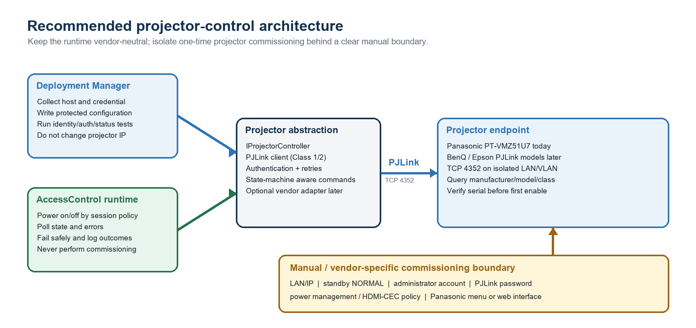
Figure 1. Recommended vendor-neutral runtime and manual commissioning boundary.

2.1 Why this split matters
- AccessControl remains portable: it sends standard PJLink commands and does not know Panasonic menu paths.
- A future Deployment Manager commissioning workflow may capture one-time evidence without turning runtime startup into a reconfiguration event.
- The projector remains recoverable with its remote control and web interface if AccessControl is unavailable.
- Future vendor-specific automation can be added behind a narrow adapter without weakening the portable PJLink path.
- Replacing a Panasonic with a compatible BenQ or Epson becomes a commissioning change, not a booking-engine rewrite.

2.2 Required five-port network topology at each simulator PC
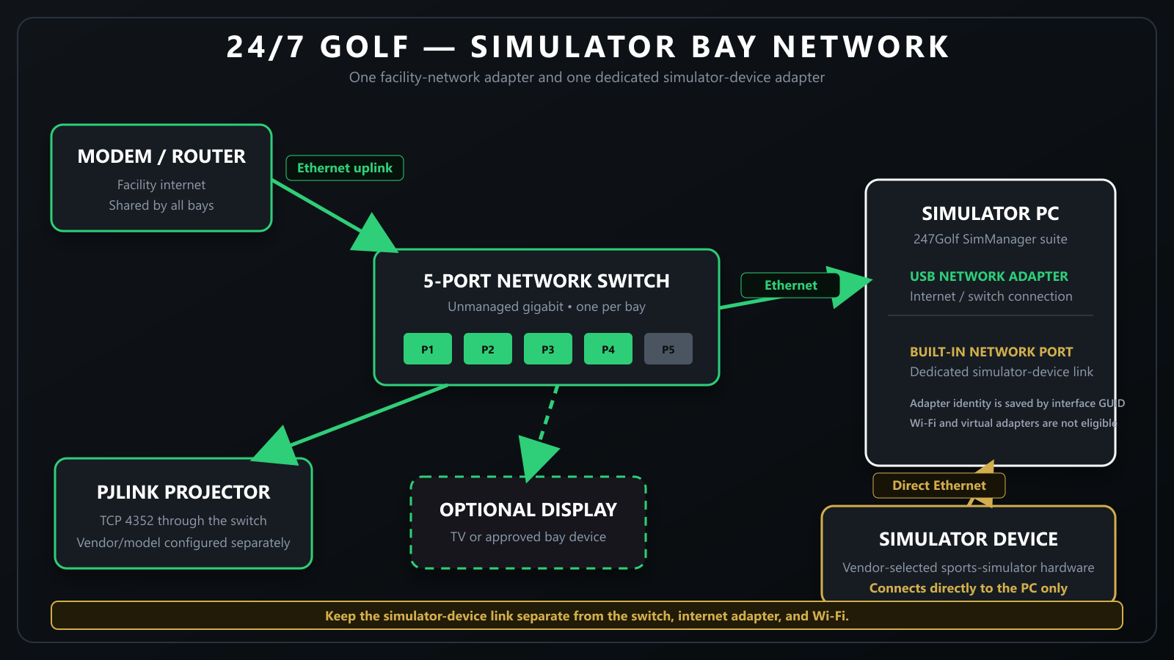
Figure 2. Required bay network: the router feeds the five-port switch; the PC USB Ethernet adapter, Panasonic projector, and optional TV share that switch; simulator device stays on a separate direct Cat6 path to the PC motherboard Ethernet port.
REQUIRED BAY LAYOUT: Install one unmanaged five-port gigabit switch at each simulator PC. Connect the facility router/network feed to the switch uplink. Connect the simulator PC to the switch through a USB Ethernet adapter. Connect the Panasonic projector's dedicated <LAN> port and, when used, the bay TV to the switch. Connect simulator device directly to the Ethernet adapter built into the PC motherboard with Cat6; never connect simulator device to the five-port switch or the USB Ethernet adapter.

CAUTION: Do not place the projector control interface on guest Wi-Fi. PJLink authentication is not a replacement for network isolation, and the protocol does not provide modern encrypted transport.

2.3 Port assignments and the two-adapter PC design
Connection | Cable path | Purpose and rule
Facility network | Internet router / upstream network -> switch uplink | Brings Internet and the facility LAN to the bay.
Simulator PC | Switch -> USB Ethernet adapter on the PC | Carries Internet, CourtReserve, support, and PJLink projector traffic. Leave Local Bind Address blank unless support intentionally pins this adapter.
Panasonic projector | Switch -> projector dedicated <LAN> port | Carries PJLink TCP 4352 and optional Panasonic web commissioning traffic.
Bay TV (optional) | Switch -> TV Ethernet port | Provides wired network service when the TV is installed and requires it.
simulator device | PC motherboard Ethernet port -> simulator device, direct Cat6 | Dedicated simulator-device path. Do not route through the switch or USB adapter.
Spare switch port | Leave unused unless an approved bay device is added | Do not use the spare port for simulator device.

3 Preparation and commissioning worksheet
CAUTION: A five-port switch normally has five usable Ethernet ports; a port used as the uplink still consumes one of them. Label the router, PC-USB, projector, optional-TV, and spare connections. Do not invent an IP address at the projector—confirm the site subnet and check for conflicts first.

3.1 Tools and access
- Panasonic remote control with working batteries and line of sight to the projector.
- A labeled set of known-good Cat6 cables, a five-port unmanaged gigabit switch, and a USB Ethernet adapter for the PC's facility-network/PJLink path.
- Administrator access to the simulator PC.
- Authority to reserve or assign an IPv4 address on the site network.
- A secure credential record for the projector administrator and PJLink passwords.
- The projector powered from its normal always-available circuit; do not use a switched outlet that removes standby power.

3.2 Record before changing anything
The Ludington SIM1 values below are the approved development and test baseline. Copy the Panasonic model and recommended menu policy, but assign and verify location-specific network identity. Never reuse SIM1's serial number, MAC address, or IP address on another physical bay.
Field | Approved Ludington SIM1 baseline | Site verification
Location / simulator | Ludington SIM 1 | ________________
Projector model | Panasonic PT-VMZ51U7 | ________________
Expected serial (SNUM) | GA5449466 | ________________
Expected projector name (NAME) | PRJ_SIM1 (device reports NAME unsupported) | ________________
Projector wired MAC | B8:20:8E:CA:7E:66 | ________________
Network topology | Five-port switch; PC through USB Ethernet | ________________
Projector IPv4 | 192.168.1.21 | ________________
Subnet mask | 255.255.255.0 | ________________
Default gateway | 192.168.1.1 | ________________
DNS1 | 192.168.1.1 | ________________
DNS2 | Blank | ________________
Address method | Manual static | ________________
PC Local Bind Address | Blank; Windows chooses USB-adapter route | ________________
Panasonic administrator user | dispadmin | ________________
PJLink password | Unique site secret; store securely | ________________
Expected simulator input | Record HDMI1 or HDMI2 | ________________
simulator device cable | Direct Cat6 to motherboard Ethernet | ________________

3.3 Naming convention
Projector on-device name: Panasonic allows up to eight characters. The approved Ludington SIM1 value is PRJ_SIM1. Use a compact unique label for other bays, avoid personal names, and remember that the installed PT-VMZ51 reports the PJLink NAME query as unsupported—serial identity remains authoritative.
AccessControl Expected Projector Name (NAME): Enter the compact on-device name, such as PRJ_SIM1. The installed PT-VMZ51 reports this query as unsupported, so manufacturer, model, and exact serial remain the required identity guards.

4 Connect the Panasonic PT-VMZ51U7

4.1 Use the dedicated LAN terminal
- Put the projector in standby and confirm the power cord remains connected.
- Connect the control-network cable to the projector's dedicated <LAN> RJ-45 terminal.
- Connect the other end to the bay's five-port switch. The PC reaches this switch through its USB Ethernet adapter.
- Do not connect the same network to both <LAN> and <DIGITAL LINK/LAN>.
- Label both ends with the simulator and projector identity.
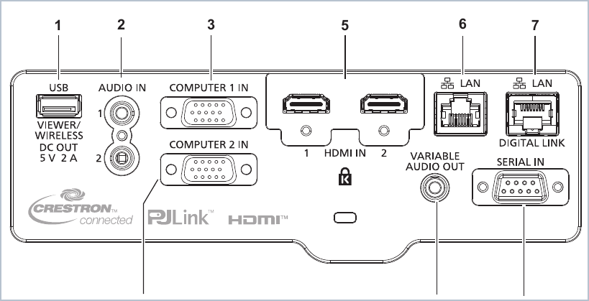
Figure 3. PT-VMZ51 terminal panel; use terminal 6 (<LAN>) for the documented five-port-switch topology. Source: Panasonic PT-VMZ71 Series Functional Manual, p. 31.
IMPORTANT: The PT-VMZ51 also has a <DIGITAL LINK/LAN> port. Use it only when the site intentionally carries Ethernet through a DIGITAL LINK/HDBaseT design. For normal PJLink control, the dedicated <LAN> terminal and ETHERNET TYPE = LAN are easier to audit.

4.2 Connect the two PC network adapters correctly
PC network interface | Connect to | Required role | Addressing
USB Ethernet adapter | Five-port switch | Facility Internet/LAN, CourtReserve, support, optional TV path, and Panasonic PJLink | Normal facility DHCP/static policy; route must reach projector 192.168.1.21 for SIM1.
Motherboard built-in Ethernet | simulator device directly with Cat6 | Dedicated simulator-device hardware path only | Use simulator-vendor-approved network configuration; do not bridge this interface to the switch.

BLOCKER: simulator device must connect directly to the motherboard Ethernet port. Do not connect it to the five-port switch, the USB Ethernet adapter, or a software network bridge. Reversing these two PC interfaces can disrupt both the simulator device and projector/Internet connectivity.

5 Configure the projector with the remote

5.1 Set standby networking to NORMAL - mandatory
- Press MENU on the Panasonic remote.
- Open PROJECTOR SETUP.
- Open ECO MANAGEMENT.
- Select STANDBY MODE.
- Set STANDBY MODE to NORMAL.
- Leave QUICK STARTUP OFF unless the location deliberately accepts its higher standby use for faster image startup.
- Return to the menu and re-open the setting to confirm NORMAL was saved.
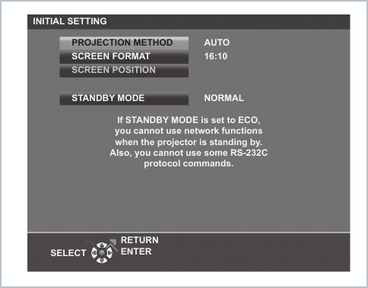
Figure 4. Panasonic initial-setting screen showing STANDBY MODE = NORMAL and warning that ECO disables standby network functions. Source: Panasonic Functional Manual, p. 48.
BLOCKER: If STANDBY MODE is ECO, the projector can appear healthy while powered on but become unreachable after shutdown. That makes PJLink power-on automation impossible.

5.2 Remove competing power automation
Menu path | Recommended value | Reason
PROJECTOR SETUP > ECO MANAGEMENT > POWER MANAGEMENT | OFF | Prevents the projector from independently shutting down during a no-signal interval while AccessControl considers a session active.
PROJECTOR SETUP > HDMI CEC | OFF | Prevents HDMI source-device power or playback events from turning the projector on/off or changing input outside the booking policy.
PROJECTOR SETUP > ECO MANAGEMENT > QUICK STARTUP | OFF (default recommendation) | Not required for PJLink. Avoids unnecessary high standby consumption; change only after a measured startup-time decision.

5.3 Select the intended Ethernet path
- Open NETWORK > ETHERNET TYPE.
- Select LAN when using the dedicated <LAN> terminal shown in Figure 3.
- Do not select LAN & DIGITAL LINK unless the site design intentionally uses both paths and prevents a network loop.

6 Configure the wired IPv4 network

6.1 Choose one stable-address strategy
Strategy | Projector setting | Recommendation
DHCP reservation | DHCP = ON; reserve the wired MAC address on the router/server. | Preferred on a managed facility network because address ownership stays centralized.
Manual static IPv4 | DHCP = OFF; enter IP, subnet mask, gateway, and DNS as approved. | Good for isolated links or sites without controllable DHCP. Verify the address is outside the DHCP pool or formally excluded.

6.2 Set the address
- Open NETWORK > WIRED LAN.
- Set IP VERSION to IPv4 for the initial AccessControl rollout.
- Open IPv4 SETTINGS.
- For a DHCP reservation, set DHCP to ON and save; then create/confirm the reservation using the projector's wired MAC address.
- For a manual address, set DHCP to OFF and enter the approved IP ADDRESS, SUBNET MASK, DEFAULT GATEWAY, DNS1, and DNS2 values.
- Select OK and press ENTER to save.
- Open NETWORK > NETWORK STATUS and record the displayed IPv4 address, subnet mask, gateway, and wired MAC address.
BLOCKER: A projector that receives a different DHCP address after a lease change will look like a failed device to AccessControl. A reservation or controlled static address is mandatory for unattended operation.

6.3 Set the projector name
- Open NETWORK > PROJECTOR NAME.
- Enter the approved unique label (maximum eight characters on this model).
- Select OK and press ENTER.
- Record the name in the commissioning worksheet. AccessControl queries NAME during Test Connection; the installed SIM1 projector reports that query as unsupported and is therefore bound by manufacturer, model, and serial.

6.4 First reachability check from Windows
ipconfig
ping <PROJECTOR-IP>
Test-NetConnection <PROJECTOR-IP> -Port 4352

- A successful ping is useful but not sufficient; some networks block ICMP.
- TcpTestSucceeded = True on port 4352 is the minimum transport check.
- Repeat the port test with the projector on, then again after it reaches standby.

7 Configure accounts and PJLink authentication

7.1 Initialize the Panasonic administrator account
- Open NETWORK > ADMINISTRATOR ACCOUNT.
- Confirm or set the user name. Panasonic's documented factory user name is dispadmin.
- Set a nonblank, unique administrator password and confirm it.
- Select STORE, confirm OK, and record the credential only in the approved secret vault.
IMPORTANT: The PT-VMZ51 manual requires an initialized administrator password before network functions, including PJLink, can be used. The administrator password and PJLink password are separate credentials.

7.2 Recommended credential rules
- Never reuse the AccessControl Admin Code, Windows password, Wi-Fi password, CourtReserve secret, or another site's projector password.
- Use a unique administrator password with at least eight characters and multiple character types.
- Use a unique 16-32 character ASCII alphanumeric PJLink password for broad client compatibility.
- Record credentials in the organization's secure vault, not in this document or on a label attached to the projector.
- Keep the projector network isolated even when authentication is enabled.

7.3 Set the PJLink password with the projector menu
- Open NETWORK > PJLink.
- Open PJLink PASSWORD.
- For CURRENT password, leave the value blank only if the factory-default blank PJLink password is still active.
- Enter the new PJLink password and its confirmation.
- Select STORE and confirm OK.
- Do not confuse this credential with the Panasonic administrator password used for the web login.
CAUTION: Panasonic documents a blank factory PJLink password, but blank authentication should be used only for a short isolated bench test. Configure a unique password before the projector is placed on a facility network.

8 Finish and verify setup from the Panasonic web interface
The browser interface is optional for PJLink operation, but it is the easiest way to review settings from the simulator PC. Temporarily set NETWORK > NETWORK CONTROL > WEB CONTROL to ON. Panasonic COMMAND CONTROL and its default port 1024 are a separate vendor-specific protocol; they are not required for PJLink on port 4352.

8.1 Sign in
- From the simulator PC, open a browser and enter http://<PROJECTOR-IP>.
- Sign in with the Panasonic administrator user name and password.
- If the interface is unavailable, re-check WEB CONTROL = ON, address/routing, and the simulator PC's active network adapter.
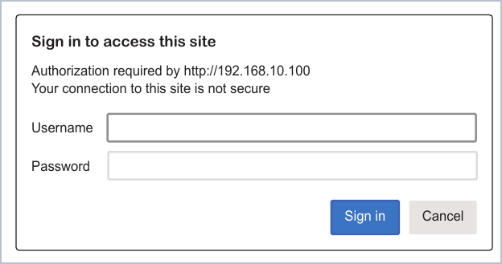
Figure 5. Panasonic web-control sign-in prompt. The address shown in Panasonic's manual is an example, not a required projector IP. Source: Panasonic Functional Manual, p. 127.
CAUTION: The Panasonic page may use plain HTTP and the browser may report that the connection is not secure. Use only the isolated trusted management network; do not expose this interface to the Internet.

8.2 Review the navigation and status
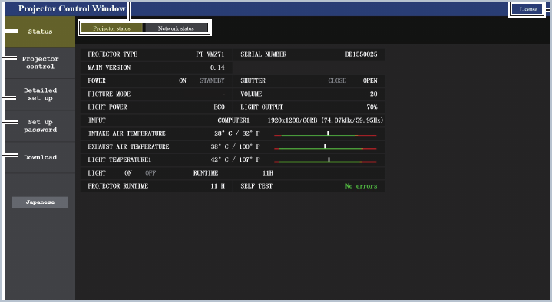
Figure 6. Panasonic Projector Control Window showing Status, Projector control, Detailed set up, and Set up password areas. Source: Panasonic Functional Manual, p. 128.
- Confirm the displayed model is PT-VMZ51.
- Confirm the wired network values match the worksheet.
- Review ECO management and ensure STANDBY MODE remains NORMAL.
- Use the built-in ping test only as a supplementary diagnostic; the simulator PC must still prove port 4352 reachability.

9 Set or change the PJLink password in the browser
- Select Set up password in the left navigation.
- Choose the PJLink account, then select Next.
- Enter the new PJLink password.
- Select Change.
- Immediately update the secure vault record and any lab client configuration.
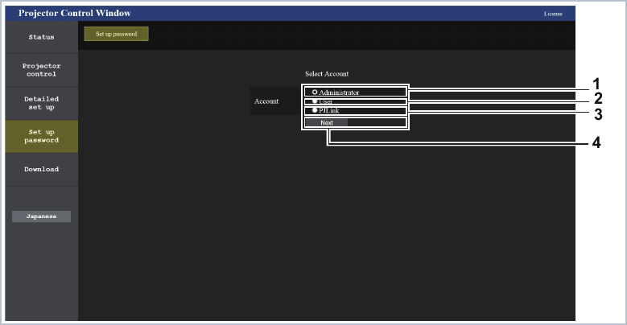
Figure 7. Select the PJLink account under Set up password. Source: Panasonic Functional Manual, p. 139.
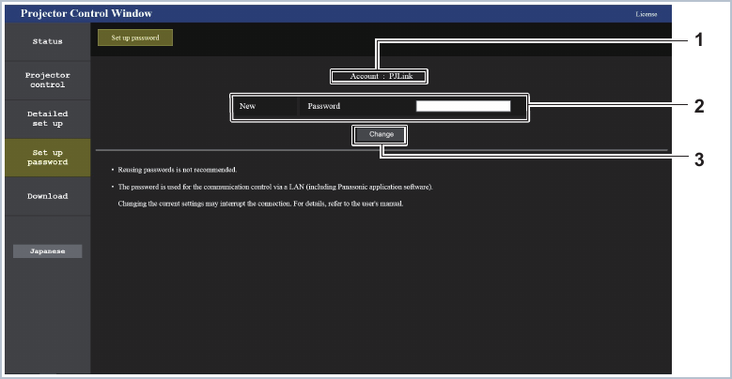
Figure 8. PJLink password change page in Panasonic web control. Source: Panasonic Functional Manual, p. 141.
CAUTION: Changing the PJLink password immediately invalidates stored client credentials. Perform the change during commissioning, then re-run authentication and power/status tests before leaving the site.

10 Final Panasonic PT-VMZ51U7 settings profile
Setting | Required / recommended value | Criticality
Physical port | Dedicated <LAN> terminal; one network path only | Required
NETWORK > ETHERNET TYPE | LAN | Required for the documented topology
NETWORK > WIRED LAN > IP VERSION | IPv4 | Required for first rollout
IPv4 address | DHCP reservation or controlled static address | Required
NETWORK > PROJECTOR NAME | Unique 8-character site/bay label | Recommended
PROJECTOR SETUP > ECO MANAGEMENT > STANDBY MODE | NORMAL | Required for power-on from standby
PROJECTOR SETUP > ECO MANAGEMENT > POWER MANAGEMENT | OFF | Required to avoid competing shutdown
PROJECTOR SETUP > HDMI CEC | OFF | Required to avoid competing power/input control
PROJECTOR SETUP > ECO MANAGEMENT > QUICK STARTUP | OFF unless deliberately approved | Recommended
NETWORK > ADMINISTRATOR ACCOUNT | Unique nonblank administrator password | Required by Panasonic
NETWORK > PJLink > PJLink PASSWORD | Unique nonblank PJLink password | Required by 24/7 Golf policy
NETWORK > NETWORK CONTROL > WEB CONTROL | ON for commissioning; site policy afterward | Optional for PJLink
NETWORK > NETWORK CONTROL > COMMAND CONTROL | OFF unless a separate Panasonic integration is approved | Not used by PJLink
Crestron / AMX | OFF unless explicitly deployed | Recommended attack-surface reduction
Input | Manually select and record HDMI1 or HDMI2 for simulator video | Required until input policy is implemented

10.1 Settings that are not PJLink prerequisites
Brightness/light power, picture mode, lens shift, keystone, aspect, screen geometry, and audio level affect the golf experience but do not determine PJLink connectivity. Document them in a separate image-calibration profile so network-control troubleshooting does not accidentally alter the calibrated picture.

11 Prepare the AccessControl PJLink settings
ENABLEMENT GATE: Keep Enable projector control OFF while wiring and Panasonic configuration are incomplete. Enter the PJLink tab values, run Test Connection, Turn Projector On, and Turn Projector Off, then enable the single switch. There are no separate session-start or session-end toggles.

AccessControl field | SIM1 default / commissioning value | Purpose and owner guidance
Enable projector control | OFF until tests pass; ON for automation | Single switch for startup gate, automatic policy, Help action, and commissioning/runtime PJLink use.
Booking Gap To Turn Projector Off (Minutes) | 30 | Automatic standby is allowed when the time to the next booking's Early Access boundary is equal to or greater than this value.
Show Starting Message (seconds) | 20 | Total visible time for the immediate status/startup dialog. The timer starts before the first network query and the X may close it early.
Protocol | PJLink | Portable standard used by the current Panasonic integration and future compatible models.
Expected Projector Name (NAME) | PRJ_SIM1 | Commissioned on-device name. The installed PT-VMZ51 returns unsupported for NAME, so serial remains authoritative.
Projector IP Address or Host Name | 192.168.1.21 | SIM1 target on the five-port-switch network. Other bays must receive a unique approved address.
PJLink TCP Port | 4352 | Standard PJLink port; do not enter Panasonic command-control port 1024.
PJLink Password | Enter the site PJLink secret | Separate from the Panasonic administrator password and protected with current-user Windows DPAPI when saved.
Local Bind Address (Optional) | Blank | Windows chooses the route through the USB Ethernet adapter. Set only for a diagnosed multi-NIC routing requirement.
Expected Manufacturer (INF1) | Panasonic | Identity guard required before a power command.
Expected Model (INF2) | PT-VMZ51 | Model-family prefix guard for PT-VMZ51U7.
Expected Serial Number (SNUM) | GA5449466 | Exact SIM1 physical-device binding. Replace when commissioning another projector.
Connection Timeout Seconds | 5 | Maximum time for each TCP connection attempt.
Command Timeout Seconds | 5 | Maximum time to wait for a PJLink response after sending a command.
Power On Warmup Seconds | 30 | Polling window used while the projector changes from standby/warming to on.
Power Off Cooldown Seconds | 60 | Polling window used while the projector changes from cooling to standby.
Retry Attempts | 2 | Bounded retries for transient transport/command failures; authentication/configuration errors are not retried blindly.
Status Poll Seconds | 10 | Normal status-poll interval; commissioning feedback may poll more frequently without overlapping requests.
Power On Command | %1POWR 1 | Standard PJLink Class 1 power-on command.
Power Off Command | %1POWR 0 | Standard PJLink Class 1 standby command.
Power Status Command | %1POWR ? | Standard PJLink Class 1 power-state query.

11.1 Credential storage and identity protection
SECURITY: AccessControl protects the saved PJLink password with current-user Windows DPAPI before writing SimulatorConfig.json. The plaintext password is used only in the running process for the authenticated PJLink handshake. Do not place it in source control, this guide, screenshots, logs, or a label on the projector. Manufacturer, model, and exact serial identity are checked before manual or automatic power commands.

12 Commissioning and acceptance tests

12.1 Transport tests
- With the projector on, run Test-NetConnection <PROJECTOR-IP> -Port 4352 and require TcpTestSucceeded = True.
- Put the projector in standby, wait until transition/cooling completes, and run the same test again.
- If the standby test fails, re-check STANDBY MODE = NORMAL before investigating application code.
- Restart the projector and simulator PC, then confirm the same IP and successful port test.

12.2 Protocol identity tests (AccessControl PJLink tab)
Query / observation | Expected SIM1 result | How AccessControl uses it
PJLink greeting | PJLINK 1 <challenge> when password is set | Authenticates with the configured PJLink password.
INF1 ? | Panasonic | Required manufacturer identity guard.
INF2 ? | PT-VMZ51 | Required model-family identity guard.
CLSS ? | 2 | Confirms the projector's PJLink class.
SNUM ? | GA5449466 | Exact authoritative physical-device binding for SIM1.
NAME ? | ERR1 / unsupported on installed unit | Reported for diagnostics; does not fail SIM1 identity because serial verification succeeds.
ERST ? | No active error/warning | Displayed by Test Connection for commissioning and diagnostics.
POWR ? | 0 standby, 1 on, 2 cooling, or 3 warming | Drives guarded power decisions and transition polling.

12.3 Power-state transition tests
Test | Expected AccessControl result | Pass evidence
Test Connection | Authenticated identity, class, error, and power state are displayed without changing power. | Status and details show the expected SIM1 identity.
Turn Projector On | Confirmation -> identity check -> POWR 1 -> poll until On or warmup limit. | Projector reaches On and the image appears.
Repeated power-on | Already-On status is accepted without a harmful duplicate transition. | No duplicate transition fault.
Turn Projector Off | Confirmation -> identity check -> POWR 0 -> Cooling -> Standby. | Projector reaches Standby within cooldown limit.
Opposite request during transition | AccessControl waits for warming/cooling to stabilize. | No rapid power cycling.
Network loss | Failure is reported/logged; booking access and kiosk operation continue. | Disconnect/reconnect test.
Authentication/identity failure | Power command is blocked with a redacted diagnostic. | No command reaches the wrong or unauthenticated device.

IMPORTANT: AccessControl polls POWR? and interprets Standby, On, Cooling, and Warming. PowerOnWarmupSeconds and PowerOffCooldownSeconds are bounded polling windows—not blind sleeps—and opposite commands are held until the projector stabilizes.

13 Field acceptance checklist
Acceptance item | Pass / Fail | Evidence or correction
Router/upstream feed reaches switch uplink | ________ | ____________________________
PC switch cable uses USB Ethernet adapter | ________ | ____________________________
Projector dedicated <LAN> port reaches switch | ________ | ____________________________
simulator device uses direct Cat6 to motherboard Ethernet | ________ | ____________________________
Optional TV is on switch or marked not installed | ________ | ____________________________
Projector model/serial/MAC match site record | ________ | ____________________________
IPv4 is unique and stable after restart | ________ | ____________________________
ETHERNET TYPE = LAN | ________ | ____________________________
STANDBY MODE = NORMAL | ________ | ____________________________
POWER MANAGEMENT = OFF | ________ | ____________________________
HDMI CEC = OFF | ________ | ____________________________
Administrator account initialized | ________ | ____________________________
Unique PJLink password saved and stored securely | ________ | ____________________________
TCP 4352 works while on and in standby | ________ | ____________________________
Test Connection identity/status pass | ________ | ____________________________
Turn Projector On reaches On | ________ | ____________________________
Turn Projector Off reaches Standby | ________ | ____________________________
Expected HDMI input/image confirmed | ________ | ____________________________
Enable projector control selected after all tests pass | ________ | ____________________________
Startup gate tested before Startup application Row 1 | ________ | ____________________________
Help Turn On Projector and X dismissal tested | ________ | ____________________________

Installer: __________________________________ Date/time: ________________________
Reviewer: __________________________________ Location: ________________________

14 Manual setup boundary and AccessControl runtime behavior

14.1 What remains manual and what software can validate
- The installer uses the Panasonic remote or web interface to configure the wired IPv4 address, STANDBY MODE = NORMAL, administrator account, PJLink password, POWER MANAGEMENT = OFF, HDMI CEC = OFF, and the intended input.
- AccessControl stores the approved host, port, identity guards, timing, commands, and DPAPI-protected PJLink password. Test Connection verifies the device without changing power.
- Turn Projector On and Turn Projector Off repeat identity verification before changing power and poll the real state transition.
- The administrator must confirm that the bay is not in customer use before either manual power test proceeds.
- PJLink cannot change Panasonic network, standby, account, password, CEC, or power-management settings. Neither AccessControl nor Deployment Manager should scrape or automate the Panasonic web pages.
- If TCP 4352 works while on but fails in standby, return to the projector menu and correct STANDBY MODE before enabling automation.
- A replacement projector requires a new stable address, serial identity, password verification, and the full acceptance checklist. Do not reuse the prior serial guard.

14.2 AccessControl - operational owner
- Use one standards-compliant, authenticated PJLink client for Settings tests, application startup, Help recovery, and booking-driven runtime control.
- Treat PJLink Enabled as the single projector-control switch; separate session-start and session-end switches are intentionally not used.
- Serialize power intent, poll status without overlapping requests, honor Warming/Cooling, and bound retries and timeouts.
- Fail safely: projector trouble never unlocks the simulator, extends a booking, suppresses a required relock, crashes the kiosk, or blocks startup beyond 60 seconds.
- Log redacted device identity, intent source, state/result, timing, retry count, and error category—never the PJLink password or authentication hash.
- Never change the projector IP, network, account, credential, standby, CEC, or Panasonic power-management settings during runtime.

14.3 When AccessControl requests power on
Trigger | Behavior
AccessControl application launch | When PJLink is enabled, the startup gate checks status and turns the projector on before Startup application Row 1.
Paid booking reaches Early Access | A local boundary timer requests On even if the next CourtReserve refresh has not yet occurred.
Valid customer booking code | Requests On immediately; customer security/dialog flow continues without waiting for warmup.
Valid Admin Code | Requests On immediately and suppresses automatic shutdown while Admin Mode is active.
Help -> Turn On Projector | Customer recovery override requests On and keeps the projector on after Help closes.
Successful/cached refresh finds an eligible booking | A booking already inside Early Access or its active window may safely request On.

14.4 When AccessControl may request standby
Automatic standby is evaluated only while the ordinary locked kiosk is showing and only after an authoritative successful booking refresh. AccessControl measures the idle interval to the next booking's Early Access boundary, not merely its scheduled start.
Locked-kiosk refresh result | Power decision
No current or future bookings | Request Standby when the projector is not already Standby/Off.
Next Early Access gap >= configured threshold | Request Standby. Equality counts; the SIM1 default threshold is 30 minutes.
Next Early Access gap < configured threshold | Preserve current state to avoid an unnecessary cooling/warmup cycle.
Refresh failed or data is unavailable | Never authorize shutdown. Cached eligible data may request On, but missing data is not an empty schedule.
Admin Mode or customer session active | Suppress automatic shutdown.
Unpaid/invalid booking occupies the interval | It cannot request On or authorize access, but its scheduled interval remains occupied so the projector is not cycled through reserved time.

14.5 Application startup gate and the Projector Startup dialog
If Enable projector control is off, AccessControl skips the projector gate: no dialog, no PJLink connection, and configured Startup applications continue normally. If it is on, AccessControl renders Checking Projector Status, Please wait... before the first network query. Standby or Warming changes the same dialog to Turning Projector On, Please wait... without restarting its timer.
Startup application Row 1 waits until both the projector reports On and the Projector Startup dialog has closed through its configured timer or the X button. One shared 60-second maximum covers status, authentication, power-on, polling, and dialog completion. At the limit, AccessControl cancels the launch-only check, closes the remaining dialog, and continues the ordered application startup plan.
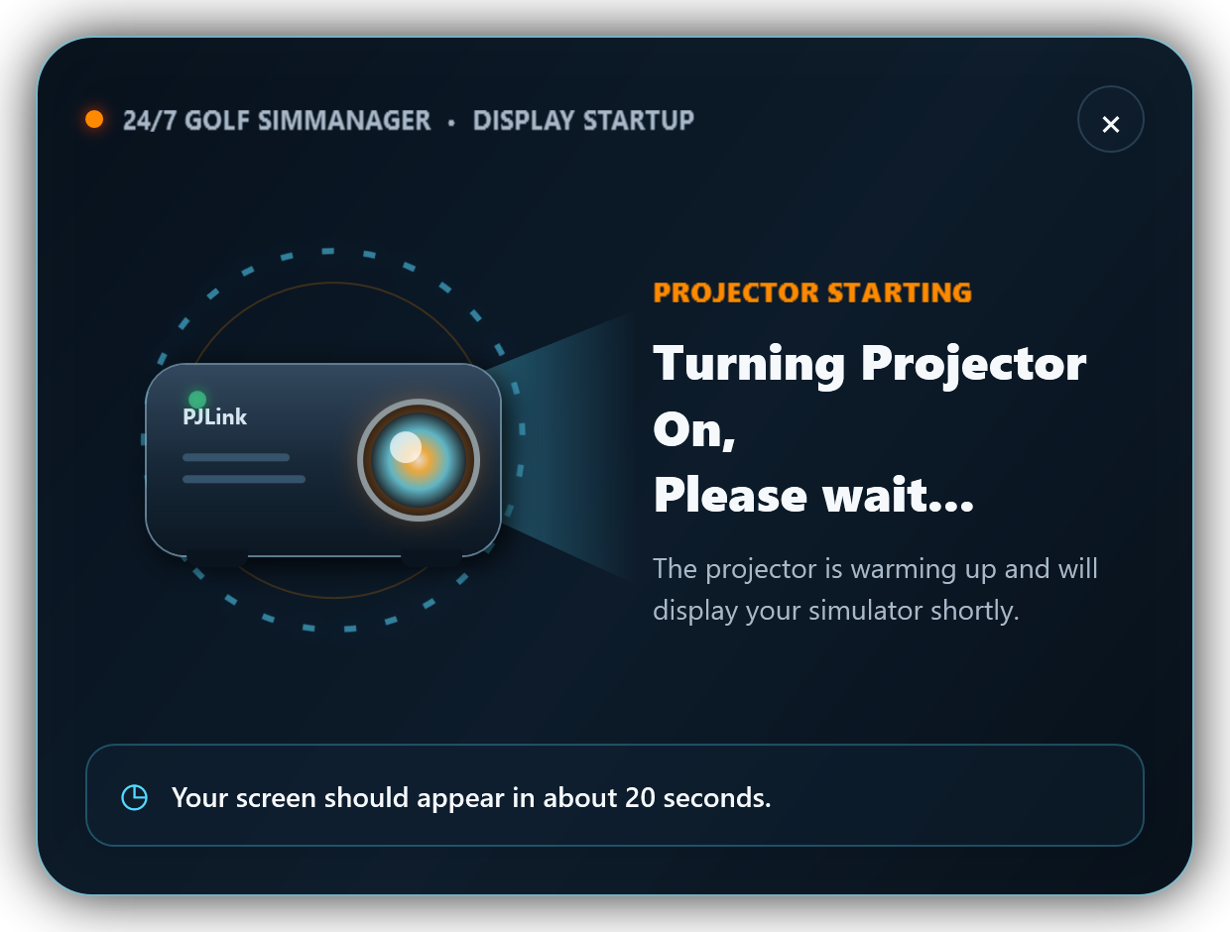
Figure 9. Actual AccessControl Projector Startup dialog in the Turning Projector On phase. The animated ring, lens, light beam, indicator, and countdown remain visible for Show Starting Message (seconds), default 20; the X closes only the message, not the PJLink operation.

14.6 Help override, kiosk return, Admin Mode, and failure protection
Help -> Turn On Projector is a customer recovery action. After the customer uses it, closing Help does not immediately turn the projector back off. The override remains until a valid customer booking-code unlock is followed by the kiosk being shown again at the end of that session. If Help is opened from an already unlocked customer session, the override ends when that session returns to the kiosk.
Entering Admin Mode does not clear the override, because Admin Mode already keeps the projector on. Turning Admin Mode off clears the override, refreshes bookings, and immediately resumes the ordinary on/off policy when PJLink remains enabled.
Every time the locked kiosk is newly presented—including startup, manual/tray relock, session-end relock, or return from a locked-kiosk dialog—the booking list refreshes and the eligible power policy is reevaluated. Newer intent supersedes older pending intent, opposite commands wait for Warming/Cooling to stabilize, and PJLink network/authentication/device failures remain isolated from access control.
OWNER RULE: The X button dismisses the customer message only. It does not cancel the power request, projector warmup, booking access, or Help override. A failed CourtReserve refresh never authorizes projector shutdown.

14.7 Why the app does not automate Panasonic web setup
Browser automation is technically possible but is the wrong product boundary. It is firmware-, layout-, language-, and browser-dependent; can strand the device by changing its address or password; and does not translate to BenQ/Epson. Use the web interface as an installer tool and use PJLink as the runtime protocol.
IMPORTANT: If a future Panasonic-only capability is essential, implement it as an optional, explicitly selected vendor adapter with its own model/firmware certification. Do not make it a hidden dependency of the portable PJLink path.

15 Recommended runtime design details

15.1 Components and dependencies
Component | Responsibility | Dependencies / consumers
PJLinkClient | TCP framing, greeting/authentication, identity, errors, status, and guarded power commands. | System.Net.Sockets, MD5 PJLink challenge response, cancellation/timeouts.
ProjectorPowerCoordinator | Serializes runtime power intent, publishes dialog phases, polls transitions, and applies newest-intent-wins behavior. | MainWindow, booking/unlock/Help policy, PJLinkClient.
ProjectorPowerPolicyEvaluator | Converts authoritative locked-kiosk booking results and gap threshold into On/Standby/preserve decisions. | CourtReserve reservation state and simulator-local clock.
HelpProjectorPowerOverride | Prevents immediate automatic shutdown after customer Help recovery and defines customer/Admin clearing rules. | Help dialog, unlock state, kiosk return, Admin Mode exit.
ProjectorStartupGate | Independent launch-only status/power check with one 60-second ceiling before Startup application Row 1. | App startup sequence and PJLinkClient.
ProjectorStartingWindow | Immediate Checking/Turning On customer feedback, animation, countdown, and dismiss-only X. | WPF UI and ShowStartingMessageSeconds.
SettingsWindow commissioning | Uses unsaved tab values for Test Connection, Turn On, and Turn Off; shows redacted status/details. | PJLinkClient and identity guards.

15.2 Minimum PJLink state model
Unknown / Unreachable -> query status
Standby (POWR=0) --On intent--> Warming (POWR=3) --poll--> On (POWR=1)
On (POWR=1) --Standby intent--> Cooling (POWR=2) --poll--> Standby (POWR=0)
Opposite intent during Warming/Cooling -> wait for stable state; newest intent wins
Authentication / identity / configuration error -> stop the command, report redacted failure, preserve kiosk access behavior

- Open one command session at a time unless the projector explicitly proves safe concurrency.
- Append a carriage-return terminator to every PJLink command.
- Handle authenticated and unauthenticated greetings, but require authentication for production policy.
- Do not retry ERRA or configuration/parameter errors as if they were transient network loss.
- Include cancellation so application shutdown and booking-state changes do not leave an unbounded operation.

15.3 Current and future command scope
Status | Commands | Current purpose
Implemented | POWR, POWR? | Manual and booking-aware power control plus authoritative transition state.
Implemented | INF1?, INF2?, CLSS?, SNUM?, NAME? | Connection-test identity, class, replacement safety, and diagnostics.
Implemented | ERST? | Connection-test device error/warning status.
Commissioning/manual | Projector menu input selection | Record and verify HDMI1 or HDMI2; AccessControl does not currently change input.
Future optional | INST?, INPT?, INPT | Input discovery/validation/restoration after model certification.
Future optional | AVMT?, LAMP?, FILT?, SVER?, IRES? | Richer maintenance diagnostics after product requirements are defined.

16 Prepare for BenQ, Epson, and other brands
Use PJLink as the common denominator, not a claim that every projector behaves identically. Each model must be commissioned and certified because supported classes, input codes, standby behavior, authentication defaults, warmup/cooldown timing, and vendor menu names vary.

16.1 Model certification record
Field | Panasonic PT-VMZ51U7 baseline | Future model result
PJLink class | Class 2 | ____________________________
Control port | 4352 | ____________________________
Standby networking setting | STANDBY MODE = NORMAL | ____________________________
Authentication configured | PJLink password | ____________________________
Power/status | POWR / POWR? | ____________________________
Simulator input code | HDMI1=31 / HDMI2=32 | ____________________________
Model/serial queries | INF2? / SNUM? | ____________________________
Measured power-on time | Site measurement required | ____________________________
Measured power-off time | Site measurement required | ____________________________
Vendor-specific conflicts | Power Management, HDMI CEC | ____________________________
Approved firmware | Record during commissioning | ____________________________

16.2 Portability rules
- Never infer support from the brand name alone; query the device and maintain a tested model/firmware matrix.
- Do not hardcode Panasonic input names or menu settings inside the protocol client.
- Retain the standard power command defaults and change them only during controlled commissioning for a certified compatible model.
- Treat vendor-specific provisioning as optional commissioning logic with clear capability detection.
- Require on-site acceptance after any projector replacement, firmware update, or network redesign.

16.3 Implementation and certification status
Phase | Status / outcome | Exit gate
0 - Panasonic commissioning baseline | Complete: detailed PT-VMZ51U7 setup, SIM1 identity, wiring, and acceptance guide. | TCP 4352 works while on and in standby.
1 - Protocol foundation | Complete: authenticated PJLink client, response parsing, identity guards, status, and power tests. | SIM1 bench power/status/identity cycle passes.
2 - AccessControl runtime integration | Complete: booking gap policy, Early Access/unlock/Help on, failure protection, transitions, dialog, and startup gate. | Focused Debug tests pass; field behavior validated at SIM1.
3 - Deployment workflow | Future: optional commissioning wizard and protected site handoff improvements. | Installer acceptance record and replacement workflow approved.
4 - Multi-brand certification | Future: certify one compatible BenQ or Epson model without changing booking policy. | Same PJLink core passes model-specific menu, timing, and site tests.

17 Troubleshooting
Symptom | Most likely causes | Corrective action
Port 4352 works while on but fails in standby | STANDBY MODE = ECO; switched outlet removed power. | Set STANDBY MODE = NORMAL; keep AC power available; retest after full standby.
Ping fails but TCP succeeds | ICMP is blocked. | Use TCP 4352 and protocol tests as the authority; document the ICMP policy.
TCP 4352 fails in all states | Wrong IP/VLAN/cable/port; USB and motherboard adapters reversed; ETHERNET TYPE mismatch. | Check switch labels, PC USB adapter, NETWORK STATUS, wired MAC, route, and projector <LAN> terminal.
simulator device is unavailable after rewiring | simulator device was connected to the switch/USB adapter or the two PC adapter roles were reversed. | Restore direct Cat6 from simulator device to the motherboard Ethernet port.
Authentication fails | Administrator password confused with PJLink password; wrong case/value; client credential mismatch. | Verify the separate PJLink password; do not brute-force.
Identity test blocks power | Manufacturer, model, or exact serial does not match; replacement projector not recommissioned. | Stop, inspect the physical label and test details, then correct/recommission the endpoint.
Projector powers off unexpectedly | Power Management/HDMI-CEC active; authoritative booking gap met; Help override already cleared. | Verify Panasonic policies, booking refresh result, threshold, kiosk/Admin state, and Help-override timeline.
Projector turns on but shows wrong input | Input was changed manually or by CEC/source device. | Disable HDMI-CEC; select and record the approved HDMI input.
Power command returns busy/error | Warmup/cooldown transition or unsupported timing. | Allow polling/backoff to finish; do not issue rapid opposite commands.
Startup applications wait too long | Projector not On, dialog still open, network/auth failure, or Show Starting Message is long. | Check the dialog/status; AccessControl continues automatically at the shared 60-second maximum.
Wrong projector responds | Reused/changing IP or duplicate configuration. | Stop automation; compare INF2/SNUM and recommission the endpoint.
Web interface works but PJLink does not | Using port 80/1024 instead of 4352; PJLink credential/client problem. | Test 4352 directly; review PJLink password and greeting/authentication.
Settings disappear after reset/replacement | Network settings separately initialized or device replaced. | Re-run the entire wiring, Panasonic configuration, identity, and acceptance process.

17.1 Safe rollback
- Set AccessControl Enable projector control to OFF.
- Control the projector with the Panasonic remote or web interface.
- Leave STANDBY MODE = NORMAL and the stable network address in place for diagnostics.
- Export/redact logs and record the exact state, response, and time of failure.
- Do not factory-reset the projector until the site settings and image calibration have been recorded.

18 Security and operational safeguards
- Place projector management on a trusted wired LAN/VLAN; block guest/client networks.
- Allow only required simulator/support hosts to reach the projector; no Internet port forwarding.
- Use a unique administrator password and a different unique PJLink password.
- AccessControl protects PJLinkPassword at rest with current-user Windows DPAPI; continue to redact it from logs, UI diagnostics, crash reports, documentation, and deployment output.
- Do not log authentication challenges, computed hashes, or raw configuration files.
- Rate-limit authentication attempts; Panasonic documents temporary browser lockout after repeated incorrect passwords.
- Record device serial identity so a DHCP conflict or swapped projector cannot receive power commands silently.
- Keep a physical remote and approved manual recovery procedure at each location.
CAUTION: PJLink authentication proves password knowledge but does not turn the control channel into an encrypted modern-management protocol. Network isolation, least privilege, endpoint identity checks, and protected local secret storage remain required.

18.1 Logging rules
Log this | Do not log this
Projector friendly name, IP/host, manufacturer, model, class, serial suffix | PJLink or administrator password
Command category and redacted command name | Authentication challenge/hash or raw credential-bearing buffers
Intent source: commissioning, session start, session end, manual test | Complete SimulatorConfig.json
State before/after, response code, duration, retry count | Unbounded raw network payloads
Network/auth/configuration/transient failure category | Customer identity or booking private data

19 References and revision history

19.1 Authoritative references
Panasonic PT-VMZ71 Series Operating Instructions / Functional Manual - https://docs.connect.panasonic.com/projector/products/vmz71/resources/
PT-VMZ51 family source for terminals, standby mode, wired LAN, accounts, web control, PJLink password, and command support. Relevant manual pages: 31, 48, 92, 103-111, 126-141, and 155-156.
JBMIA PJLink official site - https://pjlink.jbmia.or.jp/english/
Defines PJLink as the common cross-manufacturer projector-control standard.
PJLink Specifications Version 2.10 (2024-02-29) - https://pjlink.jbmia.or.jp/english/data_cl2/PJLink_5-1.pdf
Protocol framing, Class 1/Class 2 commands, search/status behavior, TCP port, and authentication.
Panasonic Integrated AV System Control comparison - https://docs.connect.panasonic.com/projector/solution/webapi/
Explains the boundary between portable PJLink and richer Panasonic-specific Web API/command control. Feature availability is model-specific.

19.2 Repository implementation references
- src/247GolfAccessControl.Core/Configuration/SimulatorOptions.cs - PJLinkOptions model and defaults.
- src/247GolfAccessControl/SettingsWindow.xaml and SettingsWindow.xaml.cs - current PJLink settings UI and persistence.
- src/247GolfAccessControl/SimulatorSettingsFile.cs - current-user Windows DPAPI protection for the PJLink secret before SimulatorConfig.json is written.
- docs/PROJECTOR_CONTROL.md - current implementation, settings, five-port bay network, startup, Help override, booking policy, and failure-protection notes.

19.3 Revision history
Revision | Date | Summary
1.0 | 2026-07-27 | Initial Panasonic PT-VMZ51U7 commissioning guide and standard/vendor boundary.
2.0 | 2026-07-28 | Added required five-port bay topology and simulator device separation; SIM1 approved defaults; all current PJLink settings; commissioning buttons; complete on/off, Help, refresh, transition, startup-gate, and customer-dialog behavior; updated security and troubleshooting.

